# Lecture # 8:

**Objective:**

* Data Grid View
* Message Box Overloads
* Tool Tip
* Menu Strip
* Context Menu

# Data Grid View:

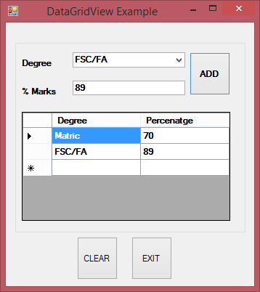

using System;

using System.Collections.Generic; using System.ComponentModel; using System.Data;

using System.Drawing; using System.Linq; using System.Text;

using System.Windows.Forms;

namespace COMBOBOX

{

public partial class DataGridViewExample : Form

{

public DataGridViewExample()

{

InitializeComponent();

}

private void btnAdd_Click(object sender, EventArgs e)

{

if (cmbxDegree.SelectedIndex == -1)

{

MessageBox.Show("Select Degree"); cmbxDegree.Focus();

}

else if (txtMarks.Text == string.Empty)

{

MessageBox.Show("Enter Percentage"); txtMarks.Focus();

}

else

{

txtMarks.Text);

try

{

}

float ehPer = float.Parse(txtMarks.Text); dgvRecords.Rows.Add(cmbxDegree.SelectedItem.ToString(),

catch (Exception)

{

MessageBox.Show("Percentage should be numeric"); txtMarks.Focus();

}

}

}

private void btnClear_Click(object sender, EventArgs e)

{

//Form2 objF = new Form2();

//objF.Show();

cmbxDegree.Text = string.Empty; txtMarks.Text = string.Empty; dgvRecords.Rows.Clear();

}

private void btnExit_Click(object sender, EventArgs e)

{

Application.Exit();

}

}

}

# Message Box Overloads:

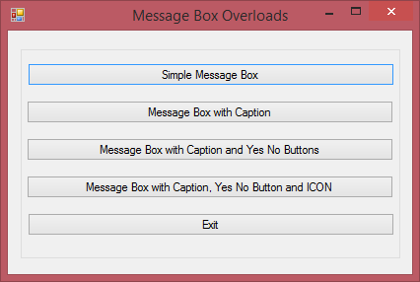

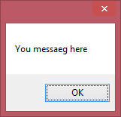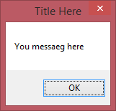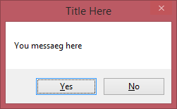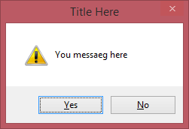

using System;

using System.Collections.Generic; using System.ComponentModel; using System.Data;

using System.Drawing;

using System.Linq; using System.Text;

using System.Windows.Forms;

namespace COMBOBOX

{

public partial class MessageBoxOverloads : Form

{

public MessageBoxOverloads()

{

InitializeComponent();

}

private void button1_Click(object sender, EventArgs e)

{

MessageBox.Show("You messaeg here");

}

private void button2_Click(object sender, EventArgs e)

{

MessageBox.Show("You messaeg here","Title Here");

}

private void button3_Click(object sender, EventArgs e)

{

DialogResult dr= MessageBox.Show("You messaeg here", "Title Here",MessageBoxButtons.YesNo);

}

private void button4_Click(object sender, EventArgs e)

{

DialogResult dr = MessageBox.Show("You messaeg here", "Title Here", MessageBoxButtons.YesNo,MessageBoxIcon.Exclamation);

}

private void button5_Click(object sender, EventArgs e)

{

Application.Exit();

}

}

}